NSW Public Spaces Legacy Program application

Submission deadline

Please send the completed form with required documentation to publicspaceslegacy@planning.nsw.gov.au by 5.00 pm on 28 August 2020.

Introduction

The NSW Public Spaces Legacy Program is a $250 million investment in new and improved public and open space projects across NSW. It is available to councils that can implement a program to accelerate the assessment of development applications and rezoning proposals.

Program objectives
The objectives are to:
- accelerate development assessment and planning proposal processes
- bring forward construction and the opportunity for jobs and economic activity in the short to medium term
- support investment in the creation of high-quality public and open spaces to create a lasting community benefit, and
- address critical open space shortfalls and improve the quality of existing public and open spaces.

Program eligibility

To be eligible for funding, councils must:
- Identify benchmark performance and opportunities to improve performance
- Commit to a local assessment acceleration program, including measurable targets, that achieve significant performance improvement, and
- Be operating on the ePlanning platform – or mandated to adopt the ePlanning platform – at the commencement of the program.

Required documentation
Please ensure that all application documentation submitted follows the below file naming standard:
Public Spaces Legacy Program - <<APPLICANT>>
Note: The Department of Planning, Industry and Environment can only receive emails of up to 50 MB. Where possible, please send extracts of documents, web links and links to cloud storage services. You can provide web links if a document (for example, council minutes) is held on a publicly available website. This should be a direct link to a specific document. For large documents, please provide page references to the text that is relevant to the project.
For questions about this application form, please email publicspaceslegacy@planning.nsw.gov.au

Contact details
Table 1. Council details
Question | Answer
Council name | Bayside Council
Address | 444-446 Princes Highway, Rockdale NSW 2216
ABN | 80 690 785 443

Table 2. Name and contact details for general manager/chief executive officer
Question | Answer
GM/CEO name | Meredith Wallace
GM/CEO email | Meredith.Wallace@bayside.nsw.gov.au
GM/CEO phone | 02 9562 1656

Table 3. Name and contact details for person completing this application (this person must be authorised by council as the nominated contact for the application)
Question | Answer
Contact name | Meredith Wallace
Email | Meredith.Wallace@bayside.nsw.gov.au
Phone | 02 9562 1656

Advice for Applicants
Your application should be as concise as possible. It should provide a very brief response to each question and supporting information should be specific to the information required to assess the proposal.
The Department will undertake an initial review of applications and contact council if more information would assist the assessment or - if necessary - to suggest adjustments.

Accelerated Planning

Implementation of ePlanning & Performance Reporting
Provide details of your progress towards full implementation of the ePlanning digital service. If you have not fully implemented the online service for development applications, please provide a timeline to show expected progress between 1 September 2020 and 31 December 2020.
The requirement for Council’s to use the ePlanning digital service to track the delivery of development applications is feasible due to Bayside Council implementing the DPIE ePlanning planning portal since 1 July 2020.

Describe the format in which you will report on council’s performance against the targets outlined in the Program Guidelines and in this form.
Metrics should, at a minimum, address assessment timeframes and allow easy comparison of the performance targets, assessment activity from 1 September 2020 to 30 June 2021, and the historical data that is submitted with your application. (refer below).
Bayside Council will provide on the 10th of each month starting October 2020 till July 2020 a report that highlights the performance.

The monthly package will include:
- Comparison of performance against targets
- Assessment activity from 1/09/20 – 30/06/21
- Regional panel DA schedule
- Planning Proposals schedule

Meeting the four key program requirements

Median Development Assessment Timeframes
Outline your current median assessment timeframes for development applications.
Information should cover at least the past 12 months, gross timeframes and (if a nett assessment timeframe is to be used for performance improvement), nett timeframes.
Fiscal Years | Median Days | Median Gross Timeframes | Median Nett Timeframes
2018 - 2020 | 104 | 104 | 104
Assessment criteria pg 9 of document titled ‘The NSW Public Spaces Legacy Program’
‘The improvement target is to be benchmarked against evidence of Councils’ assessment performance over the past 2-3 years’
Tabled below is the Median timeframes for 2018 – 2020. Calculations have been aligned to the respective fiscal years as the ‘Acceleration for Development Assessment timeframe’s’ concludes on 30 Jun 2021.
*Bayside Council assessment days are a gross calculation due to the ‘Stop the clock’ feature historically not being used.

Outline your proposal to accelerate and improve median assessment timeframes for development applications between 1 September 2020 and 30 June 2021.
Include a description of your performance improvement target, the expected improvement in overall assessment timeframes and any relevant metrics you will monitor to demonstrate achievement of the objectives for the periods between 1 September and 31 December 2020; and 1 January and 30 June 2021.
If your performance target is to refer to nett timeframes, your metrics should also include the anticipated improvements to gross assessment timeframes.
Bayside Council is committed to accelerating and improving its Median assessment timeframes for its development applications by a minimum of 20%.

Current performance (Fiscal Years 2018 – 2020) is 104 Median days
Assessment TARGET assessment days = 83 Median days

Note: Council performance targets can be found in the initial letter you received from the Department when the program was launched. If you believe your performance target should be lower, please contact the Department via publicspaceslegacy@planning.nsw.gov.au. You should nominate a proposed performance target and provide substantial justification to support your proposal including equivalent historical data, annual volume of DAs, median assessment timeframes and housing supply capacity.

Long-standing Development Applications and Rezoning Proposals
Provide details of all regionally significant development applications that have been under assessment for more than 180 days. Include a very short description of each project, its location, the applicant, the dependencies and the status of the assessment.
See attached supporting documentation. - Titled ‘Regionally Significant Development Applications’.

Provide an estimated date by which each regionally significant development application outlined above will be determined. Include major assessment milestones.
See attached supporting documentation – Titled ‘Regionally Significant Development Applications’.

Note: The Department recognises that there are some unique circumstances where there are long-standing regionally significant development applications that cannot be determined by 31 December 2020. It is recommended that council contact the Department via publicspaceslegacy@planning.nsw.gov, before it makes an application, if it intends to propose a later determination date than that specified in the Program Guidelines. The proposal should be supported by evidence, a rationale for the revised deadline, a target (eg improved average assessment timeframes), and a schedule for completing the assessments
Provide a high-level description of any undetermined rezoning proposal that has been under assessment since 1 July 2016. Include information about location, dependencies, assessment issues and any other factors impacting the determination.
Not applicable as Bayside Council does not have Planning Proposals which meet this criteria.

Provide an estimated date by which each rezoning proposal outlined above will be determined. Include major assessment milestones.
Not applicable as Bayside Council does not have Planning Proposals which meet this criteria.

Note: The Department recognises that there are some unique circumstances where there are long-standing rezoning proposals that cannot be determined by 30 June 2021. It is recommended that council contact the Department via publicspaceslegacy@planning.nsw.gov, before it makes an application, if it intends to propose a later determination date than that specified in the Program Guidelines. The proposal should be supported by evidence, a rationale for the revised deadline and a schedule for completing the assessment.

Provide a high-level plan – including a schedule – showing:
- For metropolitan councils: that your Local Environmental Plan will be updated in accordance with the Program Guidelines by 30 June 2021.
- For regional councils: that your Local Strategic Planning Statement will be completed by 30 September 2020.

Bayside is located in the Eastern City District. (Refer Figure 1) The Plan for the District sets a short term dwelling target for Bayside for 2016 to 2021 of 10,150 dwellings. 75% of the dwelling target were built between July 2016 and May 2019 and Council is on target to deliver the remainder of the short term target. In March 2020 Council adopted the inaugural Bayside Local Strategic Planning Statement which outlined how additional dwellings can be provided to meet population demand.

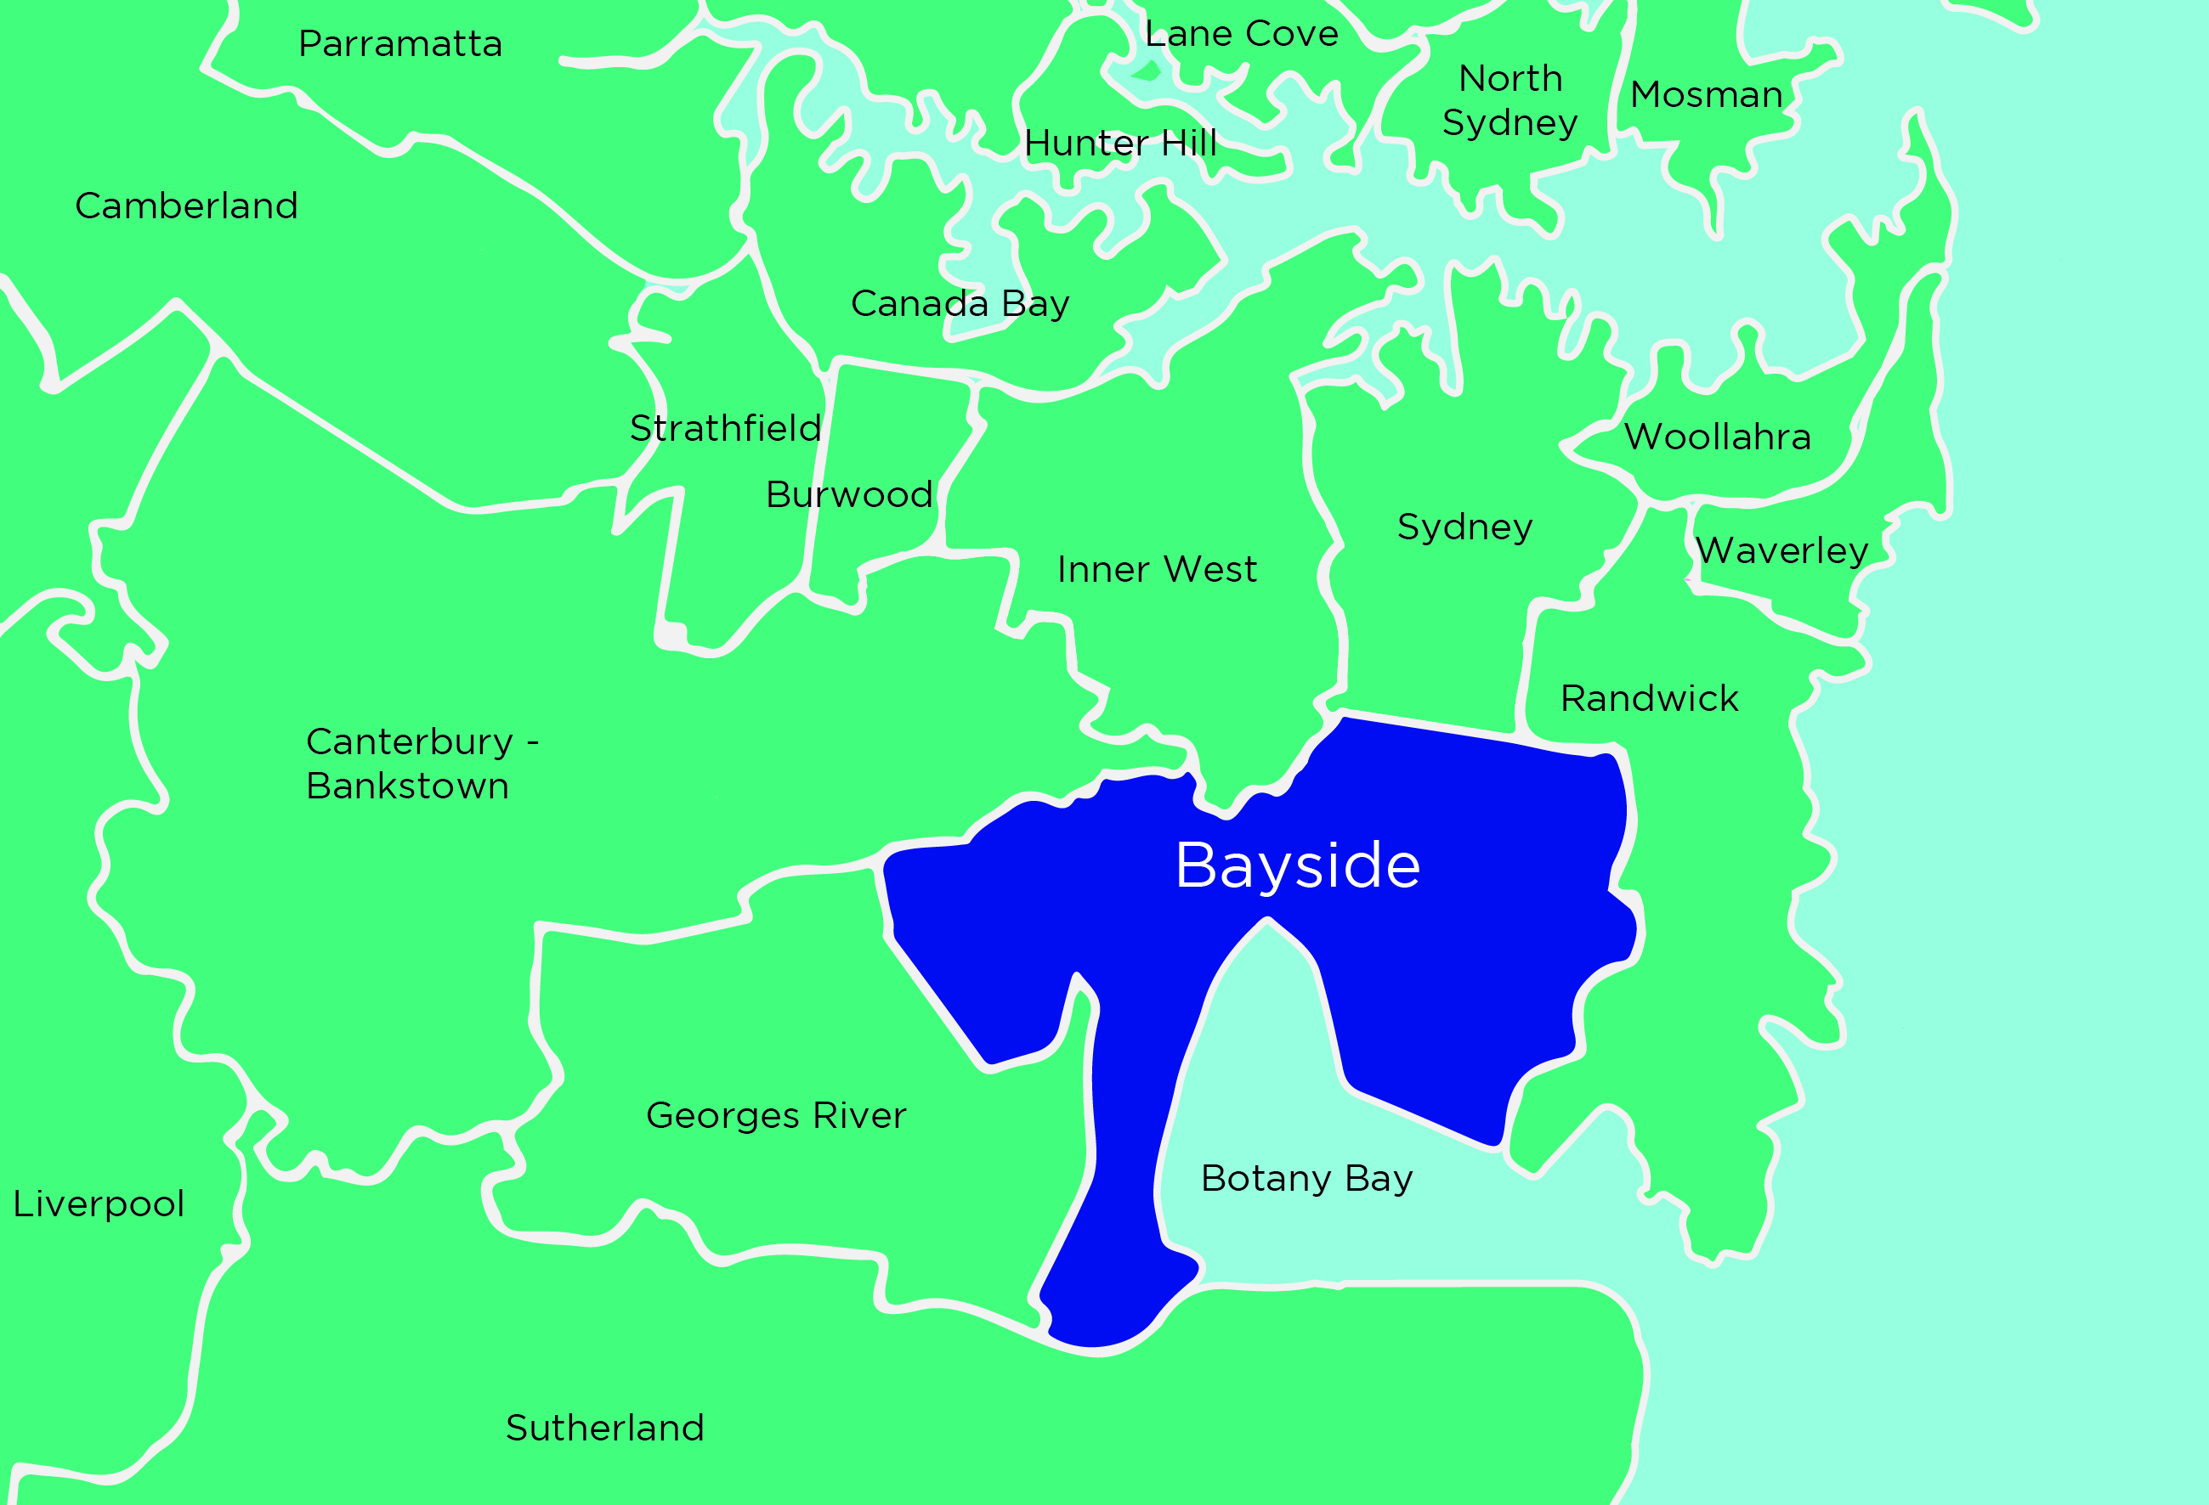
Figure 1: Location Plan

In September 2020 Bayside Council will consider a report seeking endorsement to publicly exhibit the draft Bayside Local Housing Strategy with a post exhibition report to Council anticipated in December 2020. The draft Housing Strategy identifies a number of areas for investigation to meet Councils 6-10 year housing target. Bayside’s housing target for the 6-10 year period is 7,720 dwellings. Area subject to investigation may (subject to endorsement of the Bayside Housing Strategy) include parts of Banksia, Arncliffe, Rockdale, Kogarah/Carlton, Bexley North, Bardwell Park, Brighton le Sands, Eastgardens and Ramsgate.
The timeframe for delivery of draft Planning Proposals to be exhibited by end of June 2021 is extremely tight. Council has identified the schedule required to meet that deadline. We have made the following assumptions:
- The Department of Planning, Industry and Environment will provide timely advice and issue a Gateway Determination within four weeks (20 working days) of Council request
- The Department of Planning, Industry and Environment will provide clear and timely advice to Council about issues that affect the strategic merit of planning proposals, in particular for residential intensification in relation to risk arising from land use limitations that Bayside is subject to. For instance, the Dangerous Goods Route and pipelines.
- All state and federal government agencies will provide clear and timely advice to Council as needed
- Where Council owned sites require re-classification they may need to be a ‘deferred matter’ as they could otherwise delay processing of a draft Planning Proposal.
Council will need to engage three (3) additional Senior Urban Planners for a period of 12 months, an Urban Design/Planner for nine (9) months to assist with preparation of Development Control Plan amendments required to complement proposed changes to the Local Environmental Plan. This will require an allocation of $480,000. Council will also need to allocate funds for engagement of technical consultants in the areas of urban design, traffic and transport, flooding and land use safety. This is in the order of an additional $380,000.

Exhibition of strategies | Consideration of submissions and prepare Council report | Commence PP preparation | Council report adoption of strategies | Draft LEP PP(s) finalised | BLPP Meeting | Council meeting | Submit Gateway Determination request to DPIE | DPIE issues Gateway | Exhibition
Nov 2020 | Dec 2020 | Dec 2020 | February 2021 | March 2021 | 10 April 2021 | 15 May 2021 | 16 May 2021 | 16 June 2021 | 30 June 2021

Note: It is recognised that many regional councils will have completed their LSPS prior to launch of the Program. If your council has completed its LSPS, simply note this in your application.

Benefits realisation
Describe how you will identify and record the community benefits of the acceleration program.
Recorded benefits should include anticipated construction jobs and economic benefit, and other public benefits (e.g. new or upgraded public space, infrastructure contributions and social or affordable housing) expected to be made possible through your accelerated assessment program.
If Council is successful in obtaining grant funding we will quantify the projected multiplier effect of bringing forward:
- Planning controls which facilitate supply of an additional 7720 dwellings
- Investment in public open space improvements
- Assessment of Development Applications

Note: refer to the Council Acceleration Program and the Department of Planning System Acceleration Program for benefits of the acceleration program https://www.planning.nsw.gov.au/Policy-and-Legislation/Planning-reforms/Planning-System-Acceleration-Program

Describe how you will ensure your accelerated assessment program will not impact your business as usual assessment processes, and that assessment standards will be maintained. Include information about probity, governance and oversight in the assessment process.
Bayside Council will maintain its current assessment processes including reporting of Planning Proposals and Development Applications to the Bayside Local Planning Panel. Planning Proposals will continue to be reported in a timely manner to Council and placed on public exhibition. All current governance and probity arrangements will be implemented to ensure compliance with regulations and legislation.
Improvements to timeframes for both DAs and PPs will be achieved as Council will employ additional staff resources to increase capacity.

Public and Open Spaces
Please provide a short description of a public and open space project or program that you may propose to fund under the program. Your description should include – where possible - scope, objectives, strategic alignment, location, expected project start and completion dates and a high-level estimate of cost if available.
Bayside council anticipates that the public benefits to be derived from the Program will be improved access to public open space in two areas:
Sir Joseph Banks Park
- Sir Joseph Banks Park was created in 1844 and has been a much loved and well used area of open space since that time. Council has recently prepared a Draft Conservation Management Plan which is informing preliminary Masterplanning of the park. Bayside Council has also received funding under the Metro Greenspace Program, for the Millstream and Botany Wetlands Corridor within which Sir Jospeh Banks Park is located. Early work on that project has identified the need to improve access to public and open space in the corridor.
Council has completed a playspace audit which identified Sir Joseph Banks Park as a suitable location for a Regional level playspace. The eastern part of our local government area does not have such a facility. The playspace will be aligned with the Everyone Can Play Guidelines that will also improve the park as a place which attracts a diverse range of people.

Scope
Construction of a Regional level playspace at Sir Joseph Banks Park

Project Delivery – Key Milestones
Preparation of Sir Joseph Banks Masterplan | September – November 2020 | Existing Council resources
Exhibition of Masterplan and Conservation Management Plan | November and December 2020 | Existing Council resources
Adoption of Masterplan and CMP | February 2021 | Existing Council resources
Detailed design and documentation commences | March 2021 | Grant funded resources
Construction commences | After August 2021 | Grant funded resources
Construction complete | 31 December 2022 | Grant funded resources

Council has limited funds available in the Botany Bay Development Contributions Plan 2016 for a playspace in this location. However, the grant funding will enable council to deliver a much needed Regional playspace and supporting infrastructure including new paths, lighting and ancillary facilities.

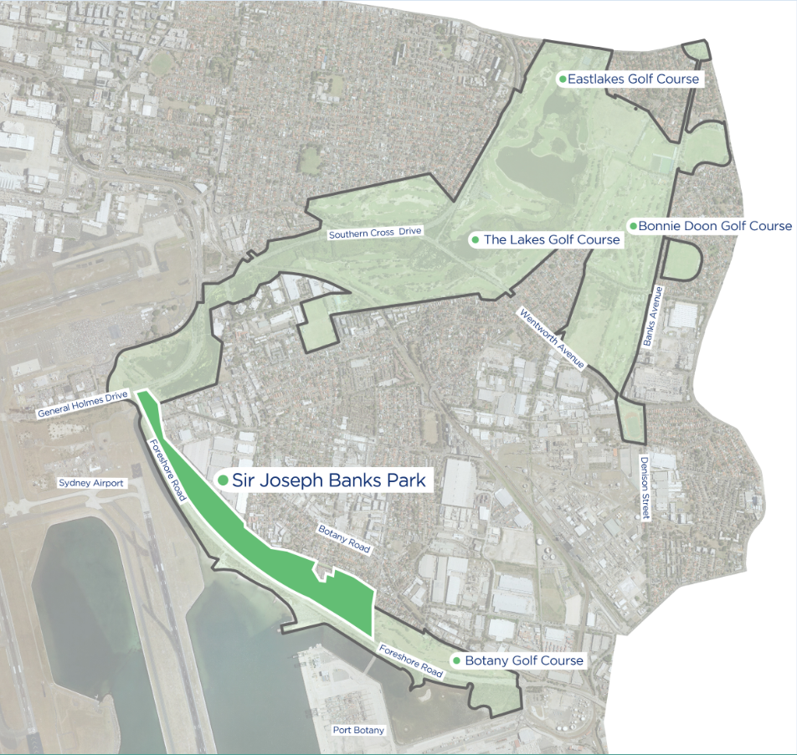

Funding application
Bayside Council is seeking Legacy Program Grant funding of $2.5M for the Sir Joseph Banks Park Regional Playspace project and supporting facilities.

Barton Park
- Barton Park is located in the Rockdale Wetlands Corridor which is also funded by the Metro Greenspace Program. Council adopted the Barton Park Masterplan in April 2020, subsequent to extensive community engagement and support. Detailed design documentation for Zone 1 (including Sporting fields, amenities building, multi function courts and playground) and Zone 2 (shared path along the western banks of Muddy Creek) commenced in July 2020.
The proposed shared path adjacent to Muddy Creek will improve access by pedestrians and cyclists to Barton Park itself as well as the broader open space corridor to the north and south. Improved access will encourage more people to the place for organised sport as well as passive recreation in a unique landscape setting.
The Muddy Creek precinct is also within the area of investigation as part of the Metro Greenspace Program and preliminary investigations indicate that an integrated framework of open space, activities and movement network will require better paths between and within key areas of public space such as this.

Scope
Construction of a shared path along the western bank of Muddy Creek, within Barton Park, between Bestic Street and Spring Street Drain.

Project Delivery – Key Milestones
Detailed design | July 2020- June 2021 | Existing Council resources
Construction tender | July 2021 | Existing Council resources
Construction commences | July 2021 | Grant funded resources
Construction completed | December 2022 | Grant funded resources
Construction complete | 31 December 2022 | Grant funded resources

Funding application
Bayside Council is seeking Legacy Program Grant funding of $3M for the construction of a shared path elevated walkway and associated viewing platforms along the western bank of Muddy Creek.

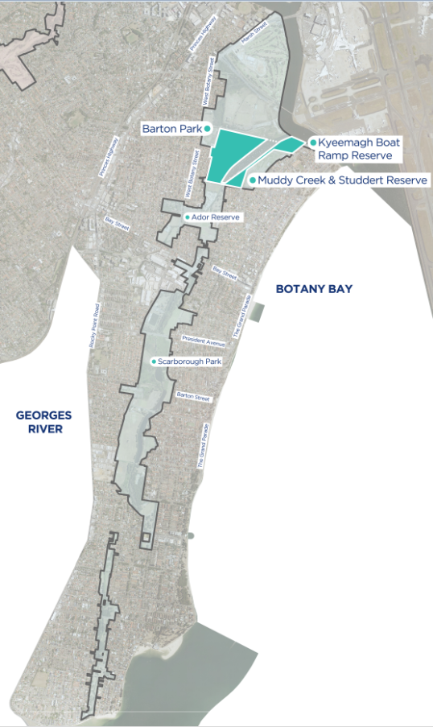
Note: The description can include multiple locations, a potential project shortlist and a high-level description of cost. The description should demonstrate alignment with the Assessment Criteria – Public and Open Space in the Program Guidelines.

State of New South Wales through Department of Planning, Industry and Environment 2020. The information contained in this publication is based on knowledge and understanding at the time of writing (August 2020). However, because of advances in knowledge, users are reminded of the need to ensure that the information upon which they rely is up to date and to check the currency of the information with the appropriate officer of the Department of Planning, Industry and Environment or the user’s independent adviser.

